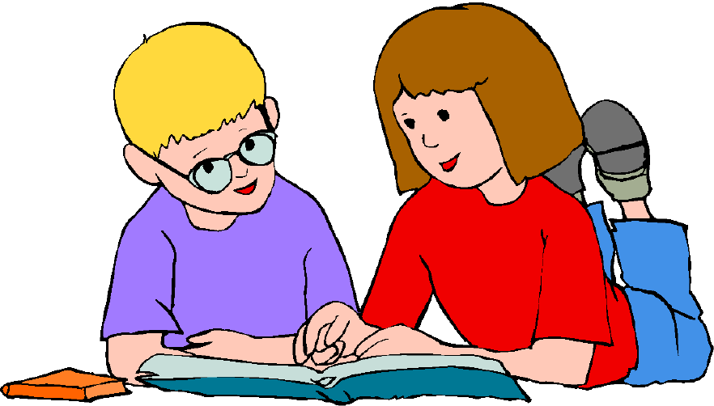
Authorial Intent: ABCs of Modernism & Post-Modernism
Prompt: With a partner or as an individual, choose either Modernism or Post-Modernism and create a children’s book to explain five of either the techniques or ideas associated with it. There is no page requirement to complete this children book. The only requirement is that you complete all that is asked of you. Since this is a children’s book, this must be presented in typical children’s book fashion. You must have text, pictures, and format your work to resemble a book.
***You have two options.***
Option 1: Create a book geared for children aged 0 – 5 in which you draw pictures with words or a few words. While it may be easy to do, you must also complete a short write up that explains how your pictures connect to the word or few words on the page.
Option 2: Create a book geared for children aged 6 – 10 in which you create a story or an educational book that teaches the concepts and terms. Consider either writing a story in which the concepts occur or having a narrator teach the concepts. This is really open and up to you! On the back of the book be sure to write down each of the five concepts you covered, and write what was your intent in writing this book.
Grade: You will be graded on creativity (5 points), neatness (5 points), concepts presented (50 points), and the back page of your book (15 points). This assignment is worth 70 points.

Authorial Intent: ABCs of Modernism & Post-Modernism
Prompt: With a partner or as an individual, choose either Modernism or Post-Modernism and create a children’s book to explain five of either the techniques or ideas associated with it. There is no page requirement to complete this children book. The only requirement is that you complete all that is asked of you. Since this is a children’s book, this must be presented in typical children’s book fashion. You must have text, pictures, and format your work to resemble a book.
***You have two options.***
Option 1: Create a book geared for children aged 0 – 5 in which you draw pictures with words or a few words. While it may be easy to do, you must also complete a short write up that explains how your pictures connect to the word or few words on the page.
Option 2: Create a book geared for children aged 6 – 10 in which you create a story or an educational book that teaches the concepts and terms. Consider either writing a story in which the concepts occur or having a narrator teach the concepts. This is really open and up to you! On the back of the book be sure to write down each of the five concepts you covered, and write what was your intent in writing this book.
Grade: You will be graded on creativity (5 points), neatness (5 points), concepts presented (50 points), and the back page of your book (15 points). This assignment is worth 70 points.

