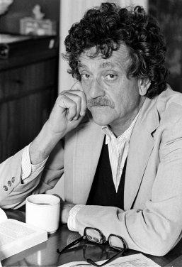
Slaughterhouse Five Analysis Project
Background: Being successful in college requires discipline in planning, time management, overcoming apathy, and staying driven. This quarter’s project asks you to demonstrate all of these skills, as well as the academic skills needed for this class. Each week there will be a dedicated focus to your studies as you research, annotate, read, analyze, question, connect, and reflect.
The purpose of this assignment is to prepare you for the similar short responses professors will ask of you in your English 101 classes. Professors want to know how you think, so their prompts relate to what they want to see about your understanding of a given text.
Prompt: Answer each specific prompt. Each week you will have specific assignments given. It is up to you to keep up with all the due dates.
Calendar:
Week 1: | 10/17 | 10/18 | 10/19  Banned Books PPT  And worksheet with videos  Hmwk: Finish worksheet | 10/20  LAB research on banned books- get one article and annotate  Hmwk: Essays due tomorrow | 10/21 Half Day  Annotate article and turn in essay  Hmwk: Finish annotating article
Week 2:  Banned Books  New Historicism Criticism | 10/24  -Read Chpt 1 & 2  -Annotate for musical connections, interesting quotes, themes, deeper meanings, and post-modernism techniques.  Hmwk: Chpt 1 & 2 | 10/25  -Read Chpt 1 & 2  -Annotate for musical connections, interesting quotes, themes, deeper meanings, and post-modernism techniques.  Hmwk: Chpt 1 & 2 | 10/26  Discussion on banned books and reading time  Hmwk: Chpt 1 & 2 | 10/27  -Compose write-up about Banned Books  Hmwk: Chpt 1 & 2 | 10/28  -Lab 238  -Type up response (Banned Books)  Hmwk: Chpt 1 & 2  Write-up due Monday
Week 3:  Kurt Vonnegut & Dresden  New Historicism Criticism | 10/31  -Collect “Banned Books” Response  -Lab 238  -Look up 2 Dresden articles &2 Kurt Vonnegut articles  Hmwk: Chpt 3 & 4  4 articles for tomorrow | 11/1  -Annotate the four articles  Hmwk: Chpt 3 & 4  4 annotated articles | 11/2  -Lab 238  -Type up responses (Kurt Vonnegut & Dresden)  Hmwk: Chpt 3 & 4  2 responses due Monday | 11/3 Five hour day  -Read Chpt 3 & 4  -Annotate for musical connections, interesting quotes, themes, deeper meanings, and post-modernism techniques.  Hmwk: Chpt 3 & 4  2 responses due Monday | 11/4 Five hour day  -Read Chpt 3 & 4  -Annotate for musical connections, interesting quotes, themes, deeper meanings, and post-modernism techniques.  Hmwk: Chpt 3 & 4  2 responses due Monday
Week 4:  Factors that Influence  New Historicism Criticism | 11/7  -Collect 2 “Kurt Vonnegut & Dresden” response.  -Read Chpt 5 & 6  -Annotate for musical connections, interesting quotes, themes, deeper meanings, and post-modernism techniques. | 11/8  Check in on Music  PPT on Factors that influence us | 11/9  -Read Chpt 5 & 6  -Annotate for musical connections, interesting quotes, themes, deeper meanings, and post-modernism techniques.  Hmwk: Chpt 5 & 6 | 11/10  -Lab 238  -Type up response (factors that influence you) | 11/11  -Share and Collect “Factors That Influence You” Response
Week 5:  Post-Modernism & Quote Analysis  Reader Response & Post-Modernism | 11/14  --Read Chpt 7 & 8  -Annotate for musical connections, interesting quotes, themes, deeper meanings, and post-modernism techniques.  Hmwk: Chpt 7 & 8 | 11/15  -Compose write-up about post-modern techniques & examples  Hmwk: Handwritten write-up | 11/16  --Read Chpt 7 & 8  -Annotate for musical connections, interesting quotes, themes, deeper meanings, and post-modernism techniques.  Hmwk: Chpt 7 & 8 | 11/17  -Lab 238  -Type up response (2 quote analysis & post-modern techniques) | 11/18  -Collect “2 Quote Analysis & Post-Modern Techniques and Examples”  -Read Chpt 9 & 10  -Annotate for musical connections, interesting quotes, themes, deeper meanings, and post-modernism techniques.
Week 6:  Deeper Questions & Reflections  Post-Modernism, Reader Response | 11/21  -Compose write-up about deeper questions  Hmwk: Handwritten write-up | 11/22  -Read Chpt 9 & 10  -Annotate for musical connections, interesting quotes, themes, deeper meanings, and post-modernism techniques.  Hmwk: Chpt 9 & 10 | 11/23  OFF | 11/24  OFF | 11/25  OFF
Week 7:  Music  Reader Response | 11/28  -Lab 238  -Type write-up (reflection & deeper questions).  Hmwk:  Have final list of songs | 11/29  -Collect “reflection & deeper questions” Response  -Lab 246  -Revise  -Print out lyrics to songs.  Hmwk: Have lyrics to all songs | 11/30  -Annotate lyrics | 12/1  -Lab | 12/2  -Lab
*Note: If you didn’t finish an activity in class, it is expected that you finish it for the next day so that you are on track to finish on time. Also, if you finish an activity early, feel free to begin the next step. There may be pop reading quizzes along the way! Be sure to keep up with the reading.
Page Set-up: Each page must be typed according to MLA format, that is to say it has 1 inch margins, has the proper header in the upper right corner (last name & page #), the proper heading on the left (your name, Johnson, Contemporary Lit, date – day month year), a title (can be creative or simply the prompt title), uses Times New Roman, size 12 font, and is double spaced.
Expectations and Grades: Each prompt is worth 15 points. A majority of the points will be awarded for your ideas and the thoughtfulness of your work. A few points will be awarded for spelling, grammar, and formatting. Every assignment must hit the required page length. If it does not meet the length requirements, points will be deducted due to a lack of thoroughness when responding.
Prompts by the Week
Week 1 and 2: Banned Books
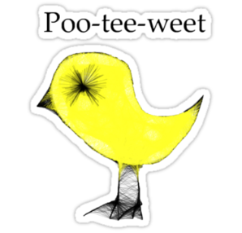
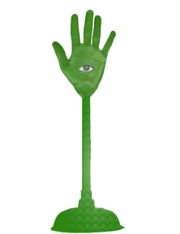
Banned Books Prompt: Write a 1 ½ - 2 page summary about book banning. Consider writing about the first amendment right, reasons why books are banned, who bans them, why Slaughterhouse Five was banned, and/or your stance.
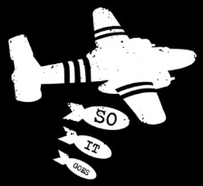
.

Week 3: Kurt Vonnegut & Dresden Bombings
Kurt Vonnegut Prompt: Write a 1 ½ to 2 page (composed of three paragraphs) summary about Kurt Vonnegut. Consider writing about his life, significant influencing factors and fun facts about Vonnegut.
Dresden Bombing Prompt: Write a 1 – 1 ½ page summary about the bombing of Dresden during WWII. Begin by providing a brief summary of the events, then analyze why this part of WWII is often times overlooked in the history classroom or history textbooks
Week 4: Factors that Influence
Factors that Influence Prompt: There are events and factors that occur in your life that influence who you are, who you become, what you do, and how you think. Write a 1 ½ - 2 page reflection of events or factors in your life that influence you. Explain the factor(s) or event(s) and how that influences you.
Week 5: Post-Modernism & Quote Analysis
Post-Modernism Prompt: Create a list of each of the post-modernism techniques, and find one example from the text of each. Write the post-modern technique and the quote below. Be sure to cite the quotes. Then briefly explain why using this literary technique is helpful to telling the story (could be 1 – 2 sentences).
Quote Analysis Prompt: In 1 1/2 pages, select 2 meaningful quotes from the novel. Write the quote, skip a line then write about a half a page analyzing the meaning of the quote and it’s significance. Consider the significance to our society, humanity, and/or the students here at OHS.
Week 6: Deeper Questions & Reflections
Deeper Questions Prompt: Slaughterhouse Five brings up several deep and thought provoking questions. Choose one of the following questions and attempt to answer it in 1 ½ - 2 pages.
- What is the significance of the quote “So it goes”?
- What is free-will and does it really exist?
- Many claim that this book is an anti-war novel. Would you agree or disagree? Why?
- What truths about life can be learned from this novel?
Reflection Prompt: Write a 1 – 2 page response to SlaughterHouse Five. Did you like or not like it? Why? What was your favorite part? Consider a favorite line, idea, or quote.
Week 7: Music
Music Prompt: Along the way, you have thought of some songs that connect to Slaughterhouse Five through theme, tone, mood, and big picture ideas. Refrain from plot based connections. Consider each track to be Tralfamadorian, as it is a “brief urgent message” about the work. Arrange the 6 – 8 songs so that each song “has [been] chosen … carefully, so that when seen all at once, they produce an image of life that is beautiful and surprising and deep” (Vonnegut 112). For each song, write-up a brief paragraph about the connections to the novel. For the set-up, write the title of the song, the singer and how long the song is, then underneath that, write your paragraph. There is no page requirement, so long as you have all of the components, and have expanded on your thoughts and ideas.

